Opisz, z czym kojarzy Ci się dany rysunek?

(podaj rejon świata, państwo, miasto, strefę roślinną itp)

Imię i nazwisko............................................... Klasa....................................

8.

1.

 ..............................................

2.

.......................................

3.

....................................

4

...............................................

5.

..........................................

6.

.....................................

7.

..................................................

......................................

9.

...........................................

10.

......................................

11.

...........................................

12.

........................................

13.

C:\Documents and Settings\Iwona\Ustawienia lokalne\Temporary Internet Files\Content.IE5\E1EPZGQS\MCj01555230000[1].wmf......................................

14. ..\MOJE DOKUMENTY\Pictures\CLIPART\HISTORY\HENGE.WMF

..................................................

15.

...............................

16.

...................................

17.

..........................................

18.

.......................................

19.

.........................

20.

................................................

21.

..................................................

22.

.......................

23.

C:\Documents and Settings\Iwona\Ustawienia lokalne\Temporary Internet Files\Content.IE5\XVIG1JXC\MCj03323520000[1].wmf……………………

24.

VENICE.WMF

25.

C:\Documents and Settings\Iwona\Ustawienia lokalne\Temporary Internet Files\Content.IE5\1JJS1O8H\MCj04343330000[1].wmf

26.

C:\Documents and Settings\Iwona\Ustawienia lokalne\Temporary Internet Files\Content.IE5\E1EPZGQS\MCj04351390000[1].wmf

27.

C:\Documents and Settings\Iwona\Ustawienia lokalne\Temporary Internet Files\Content.IE5\E1EPZGQS\MCj04062860000[1].wmf

28.

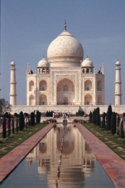

29.

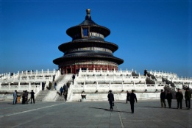

30.

C:\Documents and Settings\Iwona\Ustawienia lokalne\Temporary Internet Files\Content.IE5\3A5863VF\MCj04060760000[1].wmf

31.

C:\Documents and Settings\Iwona\Ustawienia lokalne\Temporary Internet Files\Content.IE5\3A5863VF\MCj00790390000[1].wmf

32.

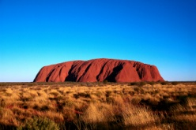

33.

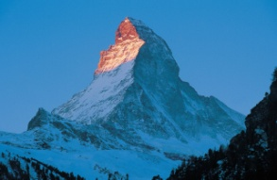

34.

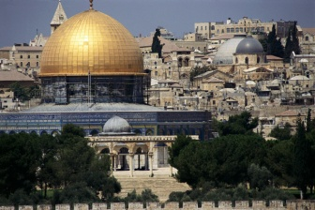

35.

C:\Documents and Settings\Iwona\Ustawienia lokalne\Temporary Internet Files\Content.IE5\1JJS1O8H\MCj01555350000[1].wmf

36.

C:\Program Files\Microsoft Office\MEDIA\CAGCAT10\j0332364.wmf

37.

C:\Documents and Settings\Iwona\Ustawienia lokalne\Temporary Internet Files\Content.IE5\E1EPZGQS\MCj04045070000[1].wmf

38.

C:\Documents and Settings\Iwona\Ustawienia lokalne\Temporary Internet Files\Content.IE5\1JJS1O8H\MCj04336940000[1].wmf

39.

C:\Documents and Settings\Iwona\Ustawienia lokalne\Temporary Internet Files\Content.IE5\4C9MYDF0\MCj03242140000[1].wmf

40.

